Tomcat installation

1. sudo apt-get update
2. sudo apt-get install default-jdk
3. sudo useradd tomcat
4. cd /tmp
5. sudo wget <https://mirrors.estointernet.in/apache/tomcat/tomcat-8/v8.5.78/bin/apache-tomcat-8.5.78.tar.gz>
6. sudo mkdir /opt/tomcat
7. sudo tar -xvf apache-tomcat-8.5.78.tar.gz
8. sudo cp -R apache-tomcat-8.5.78/* /opt/tomcat
9. sudo chgrp -R tomcat /opt/tomcat
10. sudo chmod -R g+r conf
11. sudo chmod g+x conf
12. sudo chown -R tomcat webapps/ work/ temp/ logs/
13. sudo update-java-alternatives -l
14. sudo vi /etc/systemd/system/tomcat.service

[Unit]

Description=Apache Tomcat Web Application Container

After=network.target

[Service]

Type=forking

Environment=JAVA_HOME=/usr/lib/jvm/java-1.11.0-openjdk-amd64

Environment=CATALINA_PID=/opt/tomcat/temp/tomcat.pid

Environment=CATALINA_HOME=/opt/tomcat

Environment=CATALINA_BASE=/opt/tomcat

Environment='CATALINA_OPTS=-Xms512M -Xmx1024M -server -XX:+UseParallelGC'

Environment='JAVA_OPTS=-Djava.awt.headless=true -Djava.security.egd=file:/dev/./urandom'

ExecStart=/opt/tomcat/bin/startup.sh

ExecStop=/opt/tomcat/bin/shutdown.sh

User=tomcat

Group=tomcat

UMask=0007

RestartSec=10

Restart=always

[Install]

WantedBy=multi-user.target

1. sudo systemctl daemon-reload
2. sudo systemctl start tomcat
3. sudo systemctl status tomcat
4. sudo ufw allow 8080
5. sudo systemctl enable tomcat
6. swith to root sudo su
7. chmod +x /opt/tomcat/bin/*.sh
8. vi /opt/tomcat/conf/tomcat-users.xml

<role rolename="manager-gui" />

<user username="manager" password="manager_password" roles="manager-gui" />

<role rolename="admin-gui" />

<user username="admin" password="admin_password" roles="manager-gui,admin-gui" />

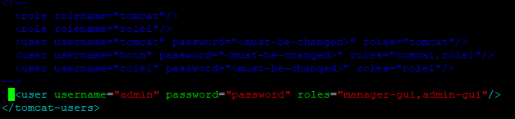

1. vi /opt/tomcat/webapps/manager/META-INF/context.xml
2. vi /opt/tomcat/webapps/host-manager/META-INF/context.xml

made below changes in both files

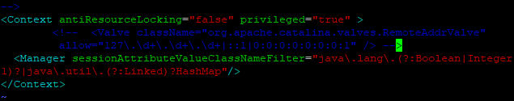

1. systemctl restart tomcat

Reverse proxy setup

1. sudo apt-get install nginx –y
2. sudo vi /etc/nginx/sites-avilable/tomcat.conf

upstream tomcat {

server 127.0.0.1:8080 weight=100 max_fails=5 fail_timeout=5;

}

server {

listen 80;

server_name 18.221.16.237;

location / {

proxy_set_header X-Forwarded-Host 18.221.16.237;

proxy_set_header X-Forwarded-Server 18.221.16.237;

proxy_set_header X-Forwarded-For $proxy_add_x_forwarded_for;

proxy_pass http://18.221.16.237:8080/;

}

}

1. sudo ln –s /etc/nginx/sites-avilable/tomcat.conf /etc/nginx/sites-enabled/
2. sudo systemctl restart nginx